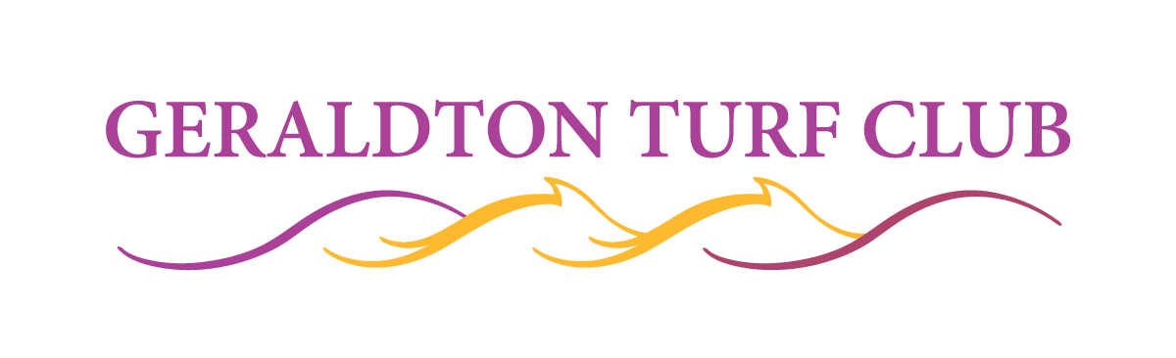
MEMBERSHIP
CORPORATE 2024/25
PO Box 440, Geraldton WA 6531
PH 9921 8366
Email: gtnturf@westnet.com.au

COMPANY NAME: ___________________________________________ _________________________________________

SURNAME: ___________________________________ FIRST NAME: ______________________________________

POSTAL ADDRESS: _________________________________________________________________POSTCODE: ___________

MOBILE: ______________________________ BUSINESS PHONE: ( )_______________________________________

E-MAIL ADDRESS: __________________________________@ ____________ ___________________________

CORPORATE MEMBERSHIP TYPE – PLEASE TICK

- PREMIUM Corporate Membership $880.00 (including GST) [ ]
(Provides 1 Member badge & 9 Guest badges)

- GENERAL Corporate Membership $660.00 (including GST) [ ]
(Provides 1 Member badge & 7 Guest badges)

- LEVEL 3 Corporate Membership $440.00 (including GST) [ ]
(Provides 1 Member badge & 4 Guest badges)

- Renewal
OR
- New Application (please complete nomination section below)

Nominated By (please print) SIGNATURE
(Only required if applying for membership)

Seconded By (please print) SIGNATURE
(Only required if applying for membership)

SIGNATURE:___________________________________________________ DATE:______/______/______

PAYMENT OPTIONS
Return this form by post or email for any direct deposit payments. Badges will not be sent out until form received at office.
NOTE NEW Bendigo Bank DETAILS.

Direct Deposit BSB: 633 000 Account No: 206 012 247 Account Name: Geraldton Turf Club Inc.

Credit Card_______________________________________Expiry Date: ____/____Visa / Master Card / Bank Card. CVC _______
All Credit Card transactions attract a 2% Surcharge.

Cheques: Make cheques payable to the Geraldton Turf Club

 PLEASE TICK IF YOU REQUIRE A COPY OF THE CLUB’S CONSTITUTION MAILED/EMAILED TO YOU.
- PLEASE READ CONDITIONS ON BACK PAGE. BY SIGNING THIS FORM YOU ACKNOWLEDGE AND UNDERSTAND THESE CONDITIONS.

Standards for Members Area



DRESS STANDARD:

The Geraldton Turf Club has a very relaxed dress standard compared to most provincial race clubs in Western Australia as we understand we are a summer race club and often race in very hot conditions.
Our members play an important role in setting our dress standards and we would ask that you are familiar with them.

It is the responsibility of a Member to ensure that their guests are appropriately dressed so as to avoid entry being refused and causing any unnecessary embarrassment.
Smart clean attire for men and women is required
No rubber thongs
For men dress sandals must have a strap
For women dress slip-ons allowed
No active sportswear, singlets, beach wear or track suits
Dirty and soiled work attire not permitted

CHILDREN:

Children are to be neatly dressed, with suitable footwear and must be supervised at all times.
Children under 18 years of age are NOT permitted near the bar area at any time.
Children should not roam around the members area.

MEMBER BADGES:

Members badges are NOT transferable and must be clearly visible at all times. Bar staff are instructed that your members badge must be clearly visible to ensure bar service.
Please be advised Security Staff are instructed to enforce the above rules.

**Members passing their badges onto others so they can gain entry into the members, face censure from the committee.
**Lost members/guest badges will incur a fee of $50 for replacement.

MEMBER DAY PASSES:

- Members are entitled to 12 complimentary Guest wristbands per season and a maximum of 4 per race meeting. NOT permitted on Ladies Day, Melbourne Cup, Walkaway Cup and Geraldton Cup Day.
- $50 per Guest on Feature Race Days (Melbourne Cup, Walkaway Cup & Geraldton Cup). This includes gate entry.
Please be aware that on the three feature dates listed a maximum of 4 day passes per membership are available to be purchased.
- $20 per Guest on all other Race Days to access the exclusive Members area.
- Complimentary Guest wristbands can be collected from the GTC office.

Please note: For the 2024/25 season there is free general admission to the public and members for all race meetings except Melbourne Cup Day, Walkaway Cup Day (December 27th) & Geraldton Cup Day. Your members benefit include free general admission on these days.

